**Name:Nadib Rana**

**ID : 213002247**

**Section:D3**

**activity_main.xml**

<LinearLayout xmlns:android="http://schemas.android.com/apk/res/android"  
 xmlns:app="http://schemas.android.com/apk/res-auto"  
 xmlns:tools="http://schemas.android.com/tools"  
 android:layout_width="match_parent"  
 android:layout_height="match_parent"  
 android:orientation="vertical"  
 android:padding="20dp"  
 android:background="#FAFAFA"  
 tools:context=".MainActivity">  
  
 <!-- Title -->  
 <TextView  
 android:layout_width="wrap_content"  
 android:layout_height="wrap_content"  
 android:layout_gravity="center"  
 android:layout_marginTop="16dp"  
 android:text="Set Alarm"  
 android:textSize="24sp"  
 android:textStyle="bold"  
 android:textColor="#333333" />  
  
 <!-- Input Field -->  
 <EditText  
 android:id="@+id/eTime"  
 android:layout_width="match_parent"  
 android:layout_height="wrap_content"  
 android:hint="Enter time in seconds"  
 android:inputType="number"  
 android:layout_marginTop="20dp"  
 android:background="@drawable/edittext_background"  
 android:padding="12dp"  
 android:textSize="16sp" />  
  
 <!-- Set Alarm Button -->  
 <Button  
 android:id="@+id/bClick"  
 android:layout_width="wrap_content"  
 android:layout_height="wrap_content"  
 android:layout_gravity="center"  
 android:layout_marginTop="20dp"  
 android:backgroundTint="@color/purple_500"  
 android:text="Set Alarm"  
 android:textColor="#FFFFFF"  
 android:textStyle="bold" />  
</LinearLayout>

ndroidManifest.xml

<manifest xmlns:android="http://schemas.android.com/apk/res/android"  
 xmlns:tools="http://schemas.android.com/tools">  
  
 <uses-permission android:name="android.permission.WAKE_LOCK" />  
  
 <application  
 android:allowBackup="true"  
 android:dataExtractionRules="@xml/data_extraction_rules"  
 android:fullBackupContent="@xml/backup_rules"  
 android:icon="@mipmap/ic_launcher"  
 android:label="@string/app_name"  
 android:roundIcon="@mipmap/ic_launcher_round"  
 android:supportsRtl="true"  
 android:theme="@style/Theme.Alarm"  
 tools:targetApi="31">  
  
 <receiver  
 android:name=".Alarm"  
 android:enabled="true"  
 android:exported="true" />  
  
 <activity  
 android:name=".MainActivity"  
 android:exported="true">  
 <intent-filter>  
 <action android:name="android.intent.action.MAIN" />  
 <category android:name="android.intent.category.LAUNCHER" />  
 </intent-filter>  
 </activity>  
  
 </application>  
</manifest>

MainActivity.java

package com.example.alarm;  
  
import androidx.appcompat.app.AppCompatActivity;  
import android.app.AlarmManager;  
import android.app.PendingIntent;  
import android.content.Intent;  
import android.os.Bundle;  
import android.view.View;  
import android.widget.Button;  
import android.widget.EditText;  
import android.widget.Toast;  
  
public class MainActivity extends AppCompatActivity {  
 EditText eTime;  
 Button bClick;  
  
 @Override  
 protected void onCreate(Bundle savedInstanceState) {  
 super.onCreate(savedInstanceState);  
 setContentView(R.layout.*activity_main*);  
  
 eTime = findViewById(R.id.*eTime*);  
 bClick = findViewById(R.id.*bClick*);  
  
 bClick.setOnClickListener(new View.OnClickListener() {  
 @Override  
 public void onClick(View v) {  
 String input = eTime.getText().toString();  
 if (input.isEmpty()) {  
 Toast.*makeText*(getApplicationContext(), "Please enter a valid time", Toast.*LENGTH_SHORT*).show();  
 return;  
 }  
  
 int i = Integer.*parseInt*(input);  
  
 // Set up the alarm  
 Intent intent = new Intent(getApplicationContext(), Alarm.class);  
 PendingIntent pendingIntent = PendingIntent.*getBroadcast*(  
 getApplicationContext(),  
 0,  
 intent,  
 PendingIntent.*FLAG_IMMUTABLE* );  
  
 AlarmManager alarmManager = (AlarmManager) getSystemService(*ALARM_SERVICE*);  
 alarmManager.set(  
 AlarmManager.*RTC_WAKEUP*,  
 System.*currentTimeMillis*() + (i * 1000),  
 pendingIntent  
 );  
  
 Toast.*makeText*(  
 getApplicationContext(),  
 "Alarm set for " + i + " seconds from now.",  
 Toast.*LENGTH_LONG* ).show();  
 }  
 });  
 }  
}

Alam

package com.example.alarm;  
  
import android.content.BroadcastReceiver;  
import android.content.Context;  
import android.content.Intent;  
import android.media.MediaPlayer;  
  
public class Alarm extends BroadcastReceiver {  
  
 @Override  
 public void onReceive(Context context, Intent intent) {  
 MediaPlayer mediaPlayer = MediaPlayer.*create*(context, R.raw.*bbbb*); // Play the alarm sound  
 mediaPlayer.start();  
 }  
}

Output:

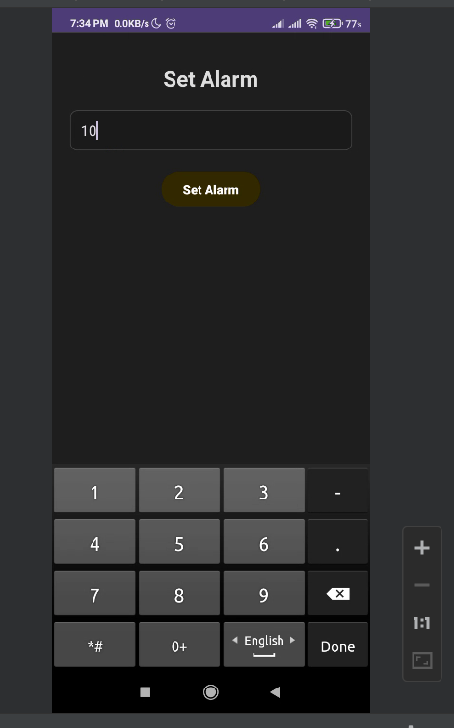

Overview:

